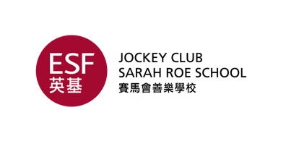

Nomination Form
I wish to propose the person named below for election to the
Jockey Club Sarah Roe School PTA Ltd Executive Committee for the year 2023-2024

Name of Nominee: ……………………………………………………………………………………………………
Email Address of Nominee: ……………………………………………………………………………………..
Parent of (Student Name): ………………………………………………………..……………………………..
Class: ……………………………………….
Position Nominated for: (Please Tick)
Chairperson
Vice-Chairperson
Honorary Treasurer
Honorary Secretary
Parent Representative

Nominated by: (Signature) ……………………………………………………………
(Name)………………………………………………………………….
Seconded by: (Signature) ………………………………………………………………
(Name)…………………………………………………………………..

This form needs to be returned to the Jockey Club Sarah Roe School office or via email to jcsrs.pta@jcsrs.edu.hk followed by the original copy of the signed form to be submitted by Friday 22nd September (3 working days prior to the Annual General Meeting).
Should you have any questions, please email jcsrs.pta@jcsrs.edu.hk.

